Experiment / Case Study 3

Experiment Title: Implement control structures and form validation; create a grading system based on user-entered marks.
Software / Tools Required: VS Code, JavaScript, HTML/CSS, Web browser
Experiment Program Code:
GradingSystem.html (HTML/CSS File)
<!DOCTYPE HTML>
<html>
<head>
<meta charset="UTF-8">
<title>Student Grading System</title>
<style>
body {
background-color: white;
color:rgb(252, 40, 40);
}

.header{
background-color: rgb(252, 40, 40);
color: white;
align-content: center;
text-align: center;
box-sizing: border-box;
border-radius: 10px;
box-shadow: rgb(0, 0, 0);
}

h2 {
font-family: 'Times New Roman', Times, serif;
}

h3 {
font-family:'Times New Roman', Times, serif;
}

.form {
background-color: rgb(37, 61, 167);
padding: 10px;
border-radius: 20px;
margin-left: 23%;
margin-right: 23%;
margin-top: 10px;
box-shadow: rgb(0, 0, 0);
}

label {
margin-left: 20px;
font-size: 25px;
font-family:Cambria, Cochin, Georgia, Times, 'Times New Roman', serif;
color: rgb(211, 203, 203);
}

input {
margin-left: 5px;
border-radius: 5px;
box-shadow: rgb(0, 0, 0);
}

.btn {
margin-top: 10px;
padding: 5px;
text-align: center;
}

button {
font-family: 'Times New Roman', Times, serif;
font-size: 20px;
}

.output {
text-align: center;
font-family: Cambria, Cochin, Georgia, Times, 'Times New Roman', serif;
font-size: 25px;
}

</style>
</head>
<body>
<div class="header">
<h2>Symbiosis Institute of Technology, Nagpur</h2>
<h3>Student Grading System</h3>
</div>
<br>
<strong style="font-size: 25px; font-family:'Times New Roman', Times, serif; margin-left: 44%;">Enter the details below</strong>
<br><br>
<div class="form">
<label>Name: </label>
<input type="name" id="name">
<br><br>
<label>Semester: </label>
<input type="number" id="sem">
<br><br>
<label>Seat No: </label>
<input type="number" id="sno">
<br><br>
<label>Marks: </label>
<input type="number" id="marks">
</div>
<div class="btn">
<button onclick="gradeSystem();">Submit</button>
</div>
<hr>
<br>
<div id="output" class="output"></div>
<h3>Designed by Arunima Das, PRN: 24070521007</h3>
<script src="GradeScript.js"></script>
</body>
</html>

GradeScript.js (JavaScript File)
function gradeSystem() {
let name = document.getElementById("name").value;
var marks = Number(document.getElementById("marks").value);

if (name === "") {
alert('Name is not given!');
return;
}

if (marks < 0 || marks > 100) {
alert('Marks are not in the correct range!');
return;
}

var grade;
var result;

if(marks >= 95) {
grade = 'O';
result = 'Outstanding';
}

else if(marks >= 90 && marks < 95) {
grade = 'A+';
result = 'Excellent';
}

else if(marks >= 80 && marks < 90) {
grade = 'A';
result = 'Very Good';
}

else if (marks >= 70 && marks < 80) {
grade = 'B+';
result ='Good';
}

else if (marks >= 70 && marks < 80) {
grade = 'B';
result ='Above Average';
}

else if (marks >= 70 && marks < 80) {
grade = 'C';
result ='Average';
}

else if (marks >= 70 && marks < 80) {
grade = 'P';
result ='Pass';
}

else {
grade = 'F';
result = 'Fail';
}

document.getElementById('output').innerHTML =
`
<h2>Student Grade Report</h2>
<br>
<b>Student Name: ${name}</b>
<br><br>
<b>Marks: ${marks}</b>
<br><br>
<b>Grade: ${grade}</b>
<br><br>
<b>Result: ${result}</b>
`
}

Output:
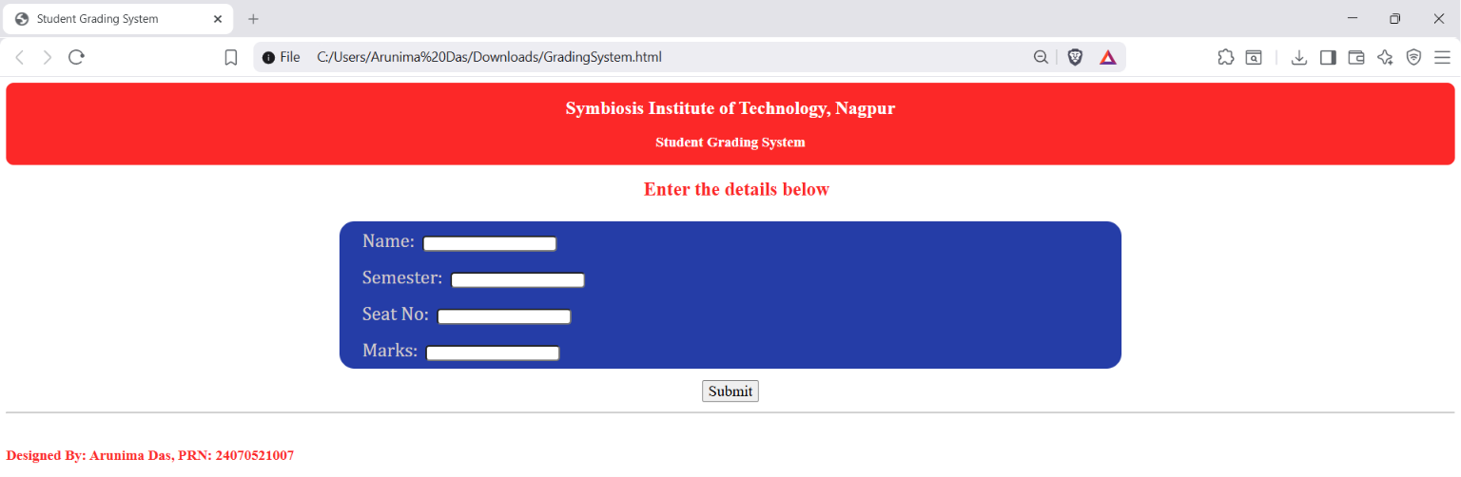

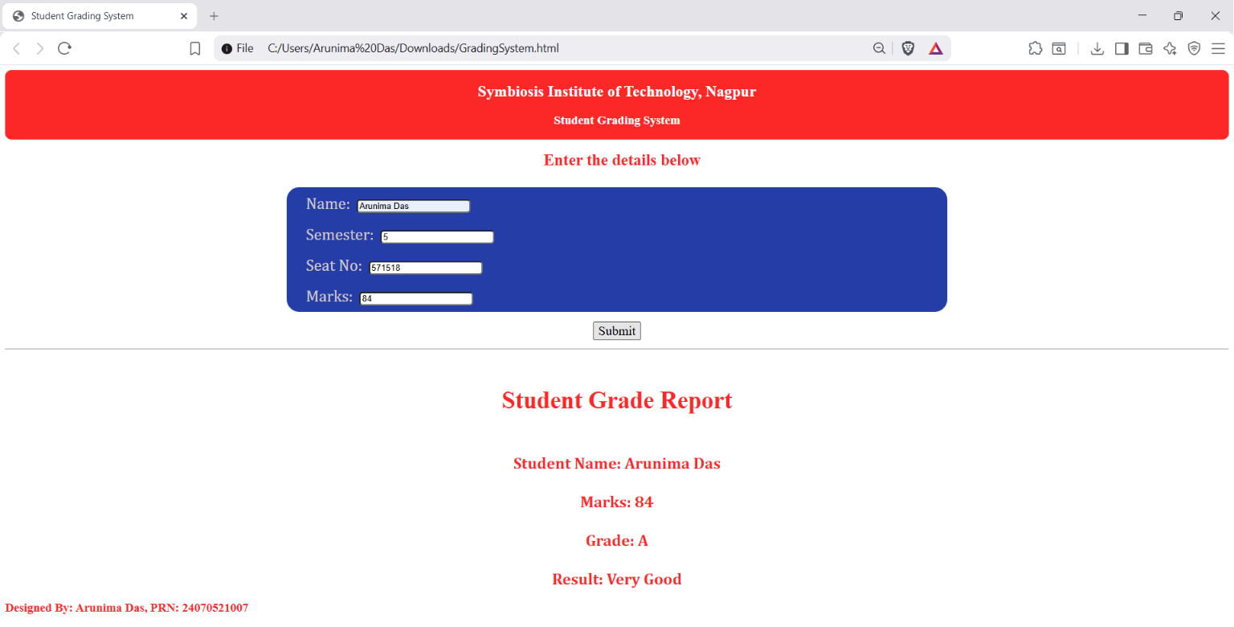

Case Study Title: Create a login form and validate the email and password. The input email should match the pattern, and the password should have atleast one lowercase letter, one uppercase letter, one digit, and one special character.
Case Study Program Code:
LoginForm.html (HTML/CSS File)
<!DOCTYPE html>
<html>
<head>
<meta charset="UTF-8">
<title>Log In</title>
<style>
body {
background-color: #82d6eb;
justify-content: center;
}

h2 {
text-align: center;
font-family:'Gill Sans', 'Gill Sans MT', Calibri, 'Trebuchet MS', sans-serif;
}

.login-card {
width: 100%;
max-width: 500px;
margin: 60px auto;
padding: 10px;
background-color: #ffe54f;
border-radius: 10px;
box-shadow: 0 10px 50px rgba(0, 0, 0, 0.1);
border: 2px solid black;
}

form {
display: flex;
flex-direction: column;
align-items: center;
width: 50%;
margin-left: 125px;
}

label {
font-family:'Gill Sans', 'Gill Sans MT', Calibri, 'Trebuchet MS', sans-serif;
font-size: 22px;
margin-bottom: 5px;
}

input {
width: 100%;
padding: 5px;
margin-bottom: 10px;
border: 1px solid #ccc;
border-radius: 5px;
box-sizing: border-box;
}

.login {
font-family:'Gill Sans', 'Gill Sans MT', Calibri, 'Trebuchet MS', sans-serif;
font-size: 22px;
background-color: #4CAF50;
color: white;
padding: 10px;
text-align: center;
display: inline-block;
cursor: pointer;
border-radius: 5px;
width: 100%;
}
</style>
</head>
<body>
<div class="login-card">
<h2 style="margin-bottom: 20px; margin-top: 10px;">Login Form</h2>
<form>
<label for="email">Email:</label><br>
<input type="email" id="email" placeholder="Enter email" required><br>
<label for="password">Password:</label><br>
<input type="password" id="password" placeholder="Enter password" required><br><br>
<button type="button" value="Log In" class="login" onclick="verifyLogin()">Log In</button>
</form>
</div>
<h3>Designed by Arunima Das, PRN: 24070521007</h3>
<script src="LoginScript.js"></script>
</body>
</html>
LoginScript.js (JavaScript File)
function verifyLogin() {
var email = document.getElementById('email').value;
var pass = document.getElementById('password').value;

if(!(email.includes('@') && email.includes('.'))) {
alert('Please enter a valid email address.');
return;
}

if(pass.length < 7 || !/[A-Z]/.test(pass) || !/[a-z]/.test(pass) || !/[\d]/.test(pass) || !/[!@#$%^&*(){}:"<>?/,.;'[]/) {
alert('Password must be atleast 7 characters long, including atleast one uppercase letter, one lowercase letter, one number, and one special character.');
return;
}

alert('You have succesfully logged in!');
}
Output:

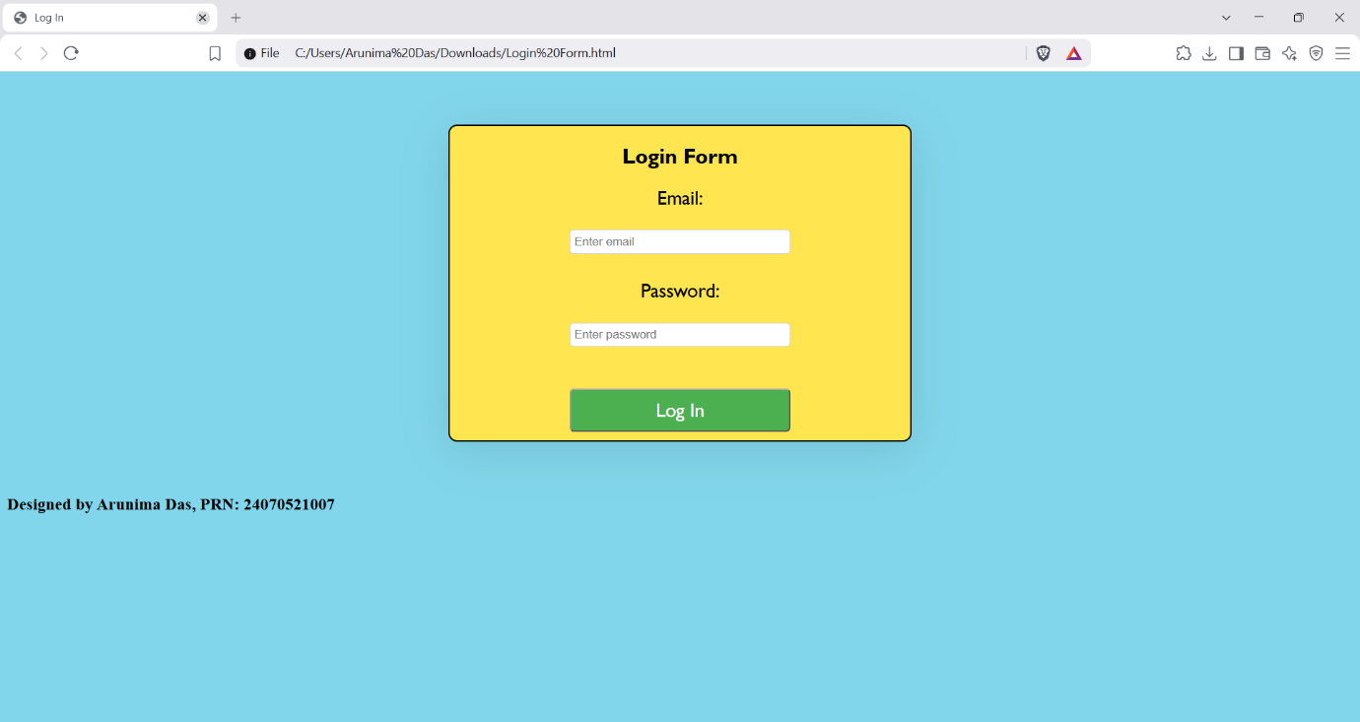
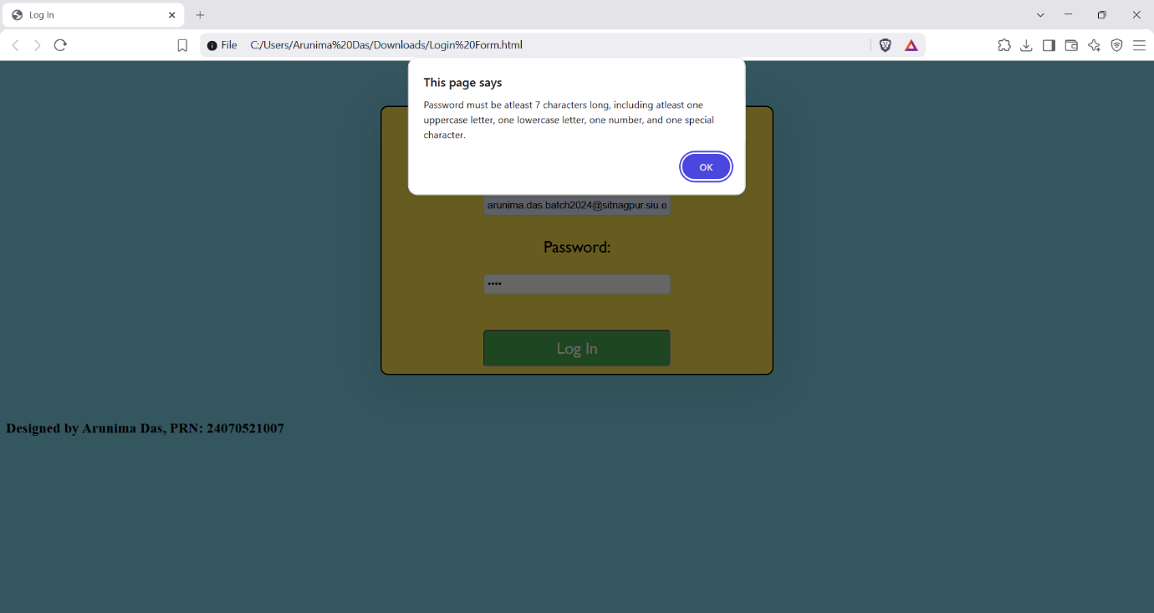
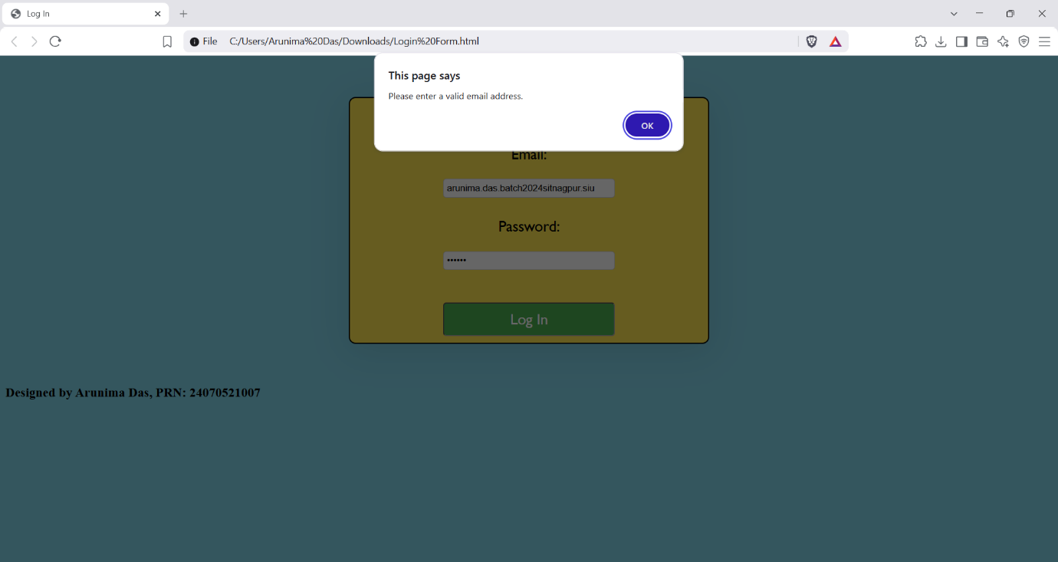
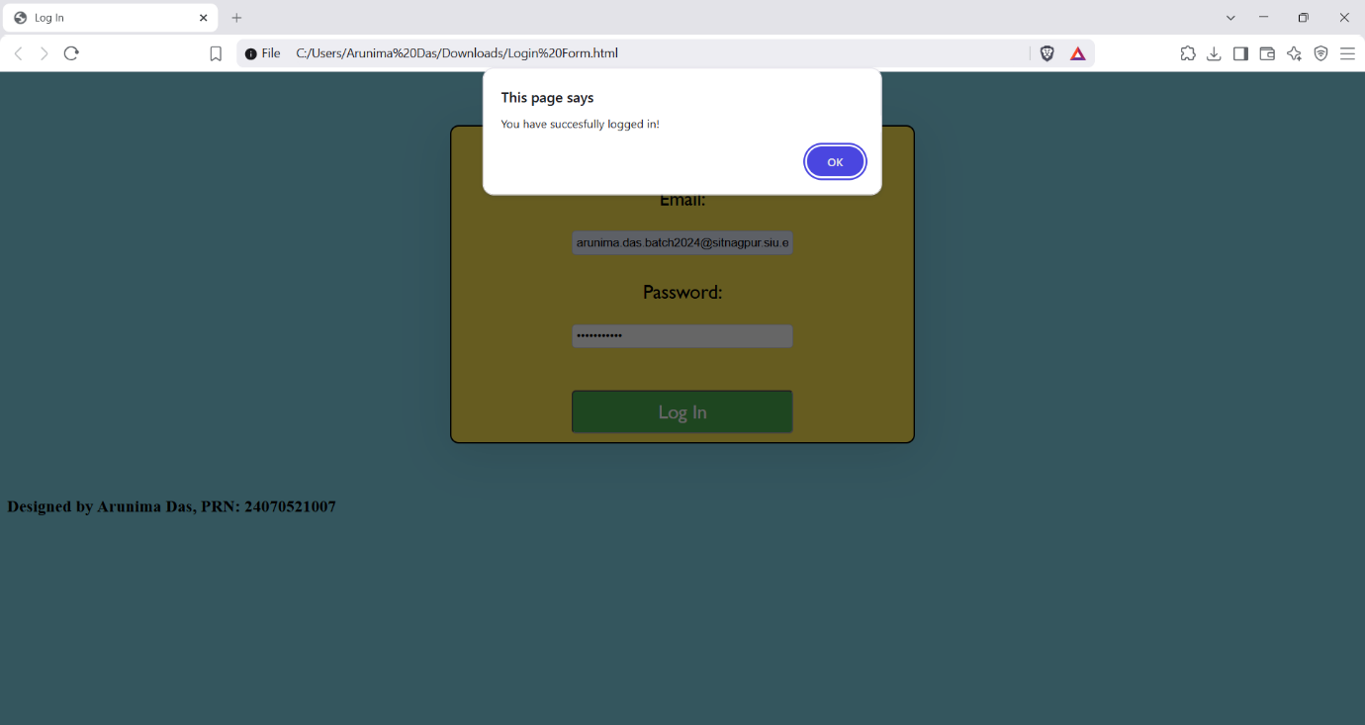

Conclusion: Thus, we can see that control structures help in categorising elements of data, and also for verifying them, for which functions are created to handle them. We will see this in the upcoming experiments.

